How to test a program using Monkey Runner API?

## Step 1: Download python.exe

Download python.exe from <http://www.python.org/download/releases/2.3.5/> and install them.

## Step 2: Set the path of Python in the system path variable

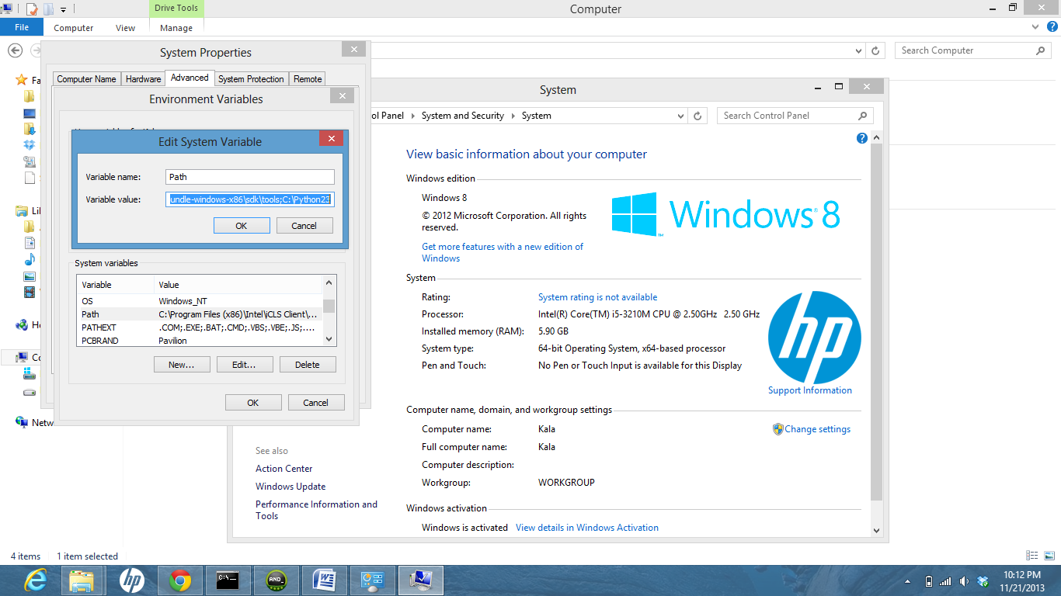

## Step 3 : Write the python script and place it inside the tools folder of SDK

Place the python script file inside the tools folder wherein Monkeyrunner.bat file is present.

Eg: C:\Kala\Android-Essential-Software-Packages\adt-bundle-windows-x86\adt-bundle-windows-x86\sdk\tools

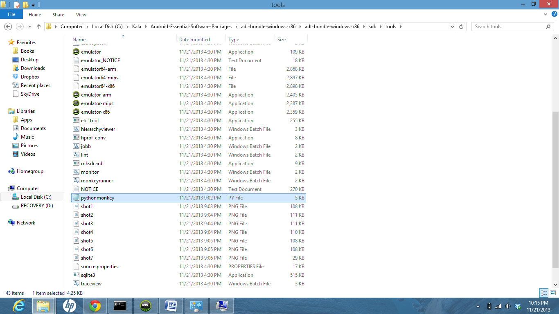

## Step 4 : Place the project folder of your application in the same folder

Place your application program in the same tools folder inorder that the python script can access the application source apk and install them.

Eg: C:\Kala\Android-Essential-Software-Packages\adt-bundle-windows-x86\adt-bundle-windows-x86\sdk\tools

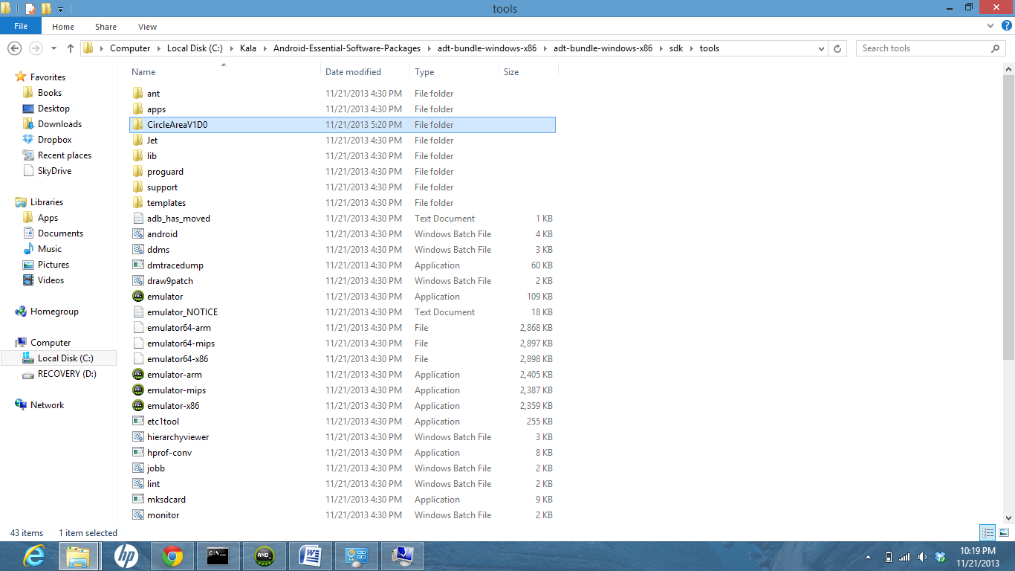

## Step 5:Execute the python script in the command window

Inorder to Execute the python script in the command window,traverse to the tools folder.Execute the python script using the command monkeyrunner <<python.py>>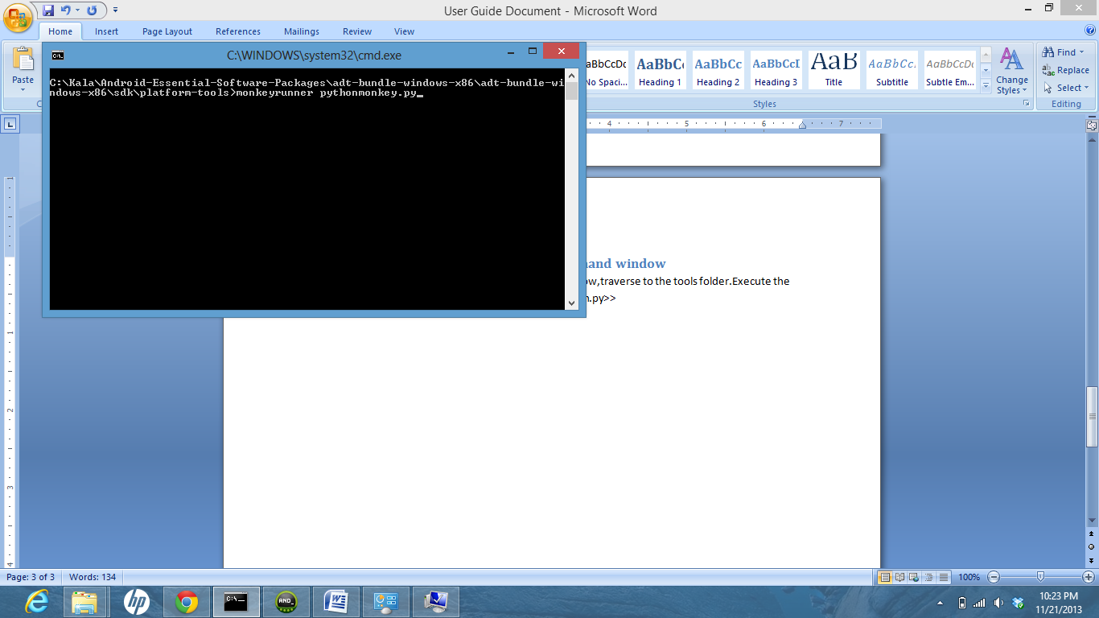

## Step 6 :Screenshots

The screenshots are generated in the tools folder and verify whether they are as expected.

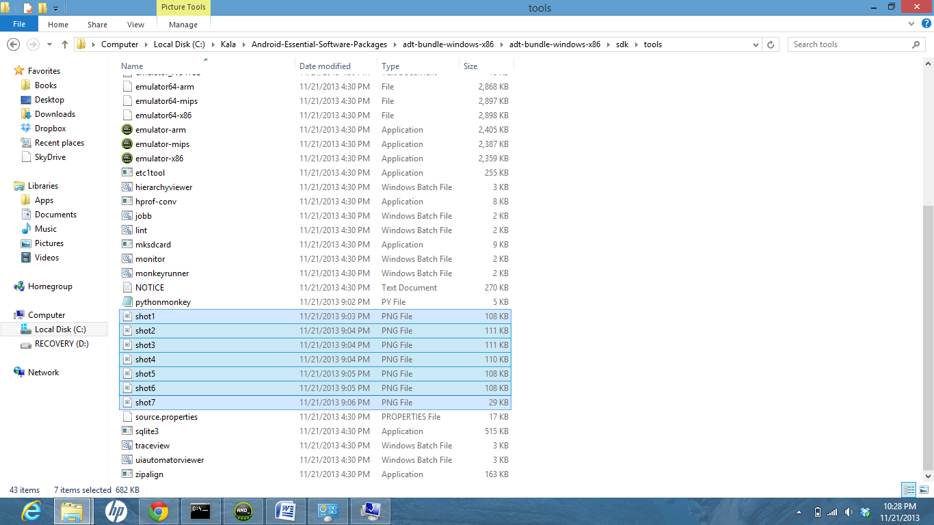

## References :

<http://www.python.org/download/releases/2.3.5/>

<http://developer.android.com/tools/help/monkeyrunner_concepts.html>